Lifecycle Policy for an S3 Bucket

* You can use lifecycle policies to define actions you want Amazon S3 to take during an object's lifetime (for example, transition objects to another storage class, archive them, or delete them after a specified period of time).
* You can define a lifecycle policy for all objects or a subset of objects in the bucket by using a shared prefix (that is, objects that have names that begin with a common string).

**Create a lifecycle policy:**

Prerequisites:

* AWS Account
* S3 Bucket
* Objects

1. Sign into the AWS Management Console and open the Amazon S3 console.
2. In the Bucket name list, choose the name of the bucket that you want to create a lifecycle policy for.

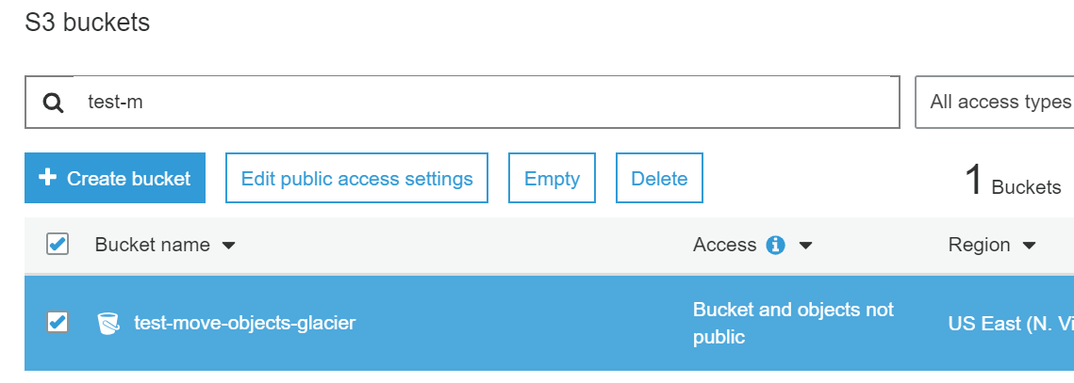s

1. Choose the Management tab, and then choose Add lifecycle rule.

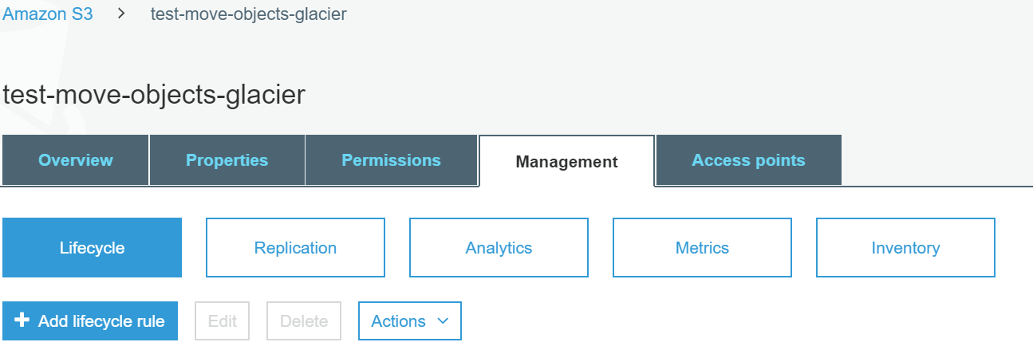

* In the Lifecycle rule dialog box, type a name for your rule. The name must be unique within the bucket. To apply this lifecycle rule to all objects with a specified name prefix (like Bureaufile folder) and choose the prefix from the drop-down list, and then press **Enter**

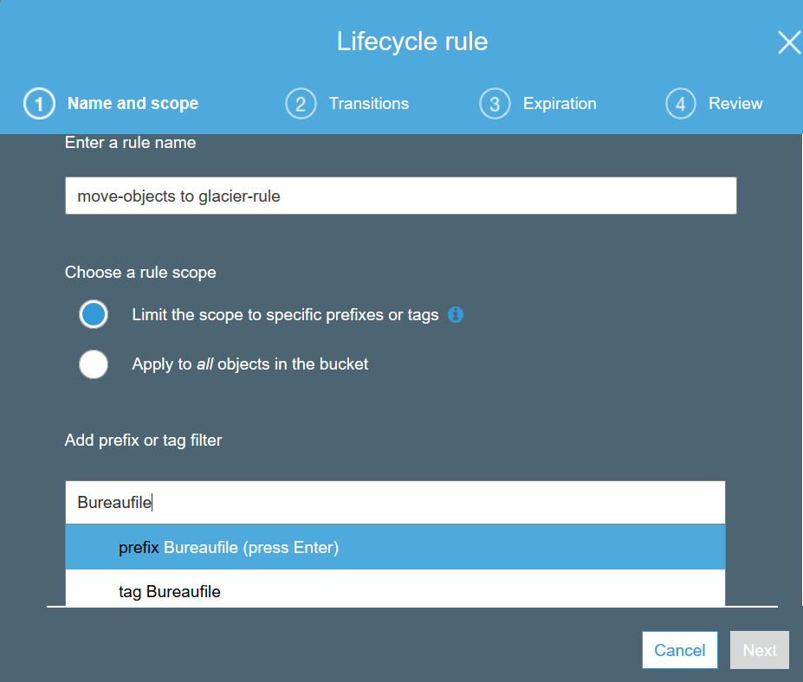

* To apply this lifecycle rule to all objects with one or more object tags, type a tag in the box, choose the tag from the drop-down list, and then press **Enter**. Repeat the procedure to add another tag. You can combine a prefix and tags. For more information about object tags, see [Object Tagging](https://docs.aws.amazon.com/AmazonS3/latest/dev/object-tagging.html) in the *Amazon Simple Storage Service Developer Guide*.
* To apply this lifecycle rule to all objects in the bucket, choose **Next**.

Storage pricing

Region:

* US East (N. Virginia)
* $0.004 per GB / Month

Retrieval pricing

Region:

* US East (N. Virginia)

| **Retrieval Time** | **Data Retrievals** |
| --- | --- |
| Expedited | $0.03 per GB |
| Standard | $0.01 per GB |
| Bulk | $0.0025 per GB |

Retrieval request pricing

Region:

* US East (N. Virginia)

| **Retrieval Time** | **Retrieval Requests** |
| --- | --- |
| Expedited | $10.00 per 1,000 requests |
| Standard | $0.05 per 1,000 requests |
| Bulk | $0.025 per 1,000 requests |